

**WOMEN SAFETY TRACKING DEVICE**

**A PROJECT REPORT**

*Submitted by*

** Shreya Rajput**

**(17BCE0542)**



**Ananya Bhatnagar**

**(17BEE0012)**

Course Code: CSE3009

Course Title: Internet of Things

Under the guidance of

**Arunkumar T**

**Senior Professor, SCOPE,**

**VIT, Vellore.**

**INDEX**

1. Abstract
2. Introduction
   1. Objective
   2. Proposed Outcome
3. Background of the Work
   1. Societal based challenges
   2. Feasibility analysis
4. Overview of the Work
   1. Working model
   2. Circuit Diagram
5. Implementation
   1. Implementation block diagram
   2. Functional Modules and Budget
   3. Source Code
   4. Test cases
   5. Execution snapshots
6. Conclusion and Future Directions
7. References

**ABSTRACT**

The main purpose of this device is to act as an emergency device for women who are in danger of being attacked. The woman possessing this device will press the panic button if in danger. An email containing the latitude and longitude coordinates will be sent to the pre fed mail ID like of the police station , informing them of the danger and the location.the received coordinates can be viewed on Google maps to determine the location. Of the woman and appropriate help can be provided.

This concept was devised in the wake of serious crime against women in India and to help curb those crimes.

**OBJECTIVE**

**Women safety application, Tracking their location in emergency and send the information to the nearby police station or family members via email appended with a google maps link**

**PROPOSED OUTCOME**

Now-a-days women are facing many problems based on their security. Cases such as snatching incidents are more frequent than ever.

The application which is proposed will:

* Access and track location and send messages to the nearby police stations and the stored email addresses.
* This application is not only used for crimes against women but this also helps them from any emergency condition or any health problem or vehicle tracking.
* GPS is to track the location of the victim and to send messages, the location of the victim to the nearby police station and the email address of the relatives of the victim. This application helps women to overcome their fear in going out and do things what they like to do.

**BACKGROUND OF THE WORK**

**Societal Based Challenges-CASE STUDY**

The status of women in India has gone through many great changes over the past few thousand years. From equal status with men in ancient times through the low points of the medieval period to the promotion of equal rights by many reformers, the history of women in India has been eventful. In modern India, women have adorned high offices in India including that of the President, Prime Minister, Leader of the Opposition and Speaker of the Lok Sabah.

However, women in India continue to face social challenges and are often victims of abuse and violent crimes and, according to a global poll conducted by Thomson Reuters, India is the “fourth most dangerous country” in the world for women, and the worst country for women among the G20 [A group of developing industrial Nations established on 20th August 2003] countries. In India, every day more than 30 women were murdered and many are suffering austere mental and physical trauma. Having this concern in mind many developers have come up with creative applications.

**Women safety issues:**

1. **Acid throwing**
2. **Domestic violence**
3. **Honor killings**
4. **Rape**
5. **Sexual harassment**
6. **Trafficking**

***In the wake of several brutal rape attacks in the capital city of Delhi, debates held in other cities revealed that some men believed women who dressed provocatively deserved to get raped; many of the correspondents stated women incited men to rape them.***

**Feasibility Analysis**

Having this concern in mind many developers have come up with creative applications.

So here we have come up to decision of taking over this issue and trying out our best to prevent it using **IoT** Technology.

Features of our device :

* ***Track the location of the woman*** (if she presses emergency button i.e. she is in emergency or uncomfortable with the surroundings.
* ***Access the location of the concerned woman***
* ***Immediately send email alerts with attached Google map link of her location to the nearby police stations and family members.***
* **This application is not only used for preventing crimes against women but this also helps them from any emergency condition or any health problem in *any remote area* or vehicle tracking.**
* **GPS is to track the location of the victim and to send messages, the location of the victim to the nearby police station and the email address of the relatives of the victim. This application helps women to overcome their fear in going out and do things what they like to do.**

**OVERVIEW OF THE WORK**

**Working Model**

**Step by Step functioning of the System: Device End**

* The microcontroller in the device setup is serial interfaced with the GPS with a baud rate of 9600. The TX and RX ins used for communication are digital pins3 and 4
* Push button is interfaced at digital pin 5 as input. All functionalities start when this button is pressed
* The radio frequency module NRF24L01 is connected through CE and CSN to pins 7 and 8. In the device end this component acts as a transmitter
* When the push button is pressed, the GPS module is invoked and using TinyGPS++ library and function calls, the latitude and longitude values of the device are stored as a char array.
* These values are then transmitted to the server using the radio frequency module that functions as a transmitter.

**Step by Step functioning of the System: Server End**

* The microcontroller used at the server is NodeMCU which has embedded ESP module that allows access to the Internet. The server will have pre-established connection to the cloud.
* The radio frequency module at the server end will function as a receiver. It is interfaced at CE and CSN with the digital pins 4 and 8.
* In the setup function, we open the listening port of the radio frequency module.

**Circuit Diagram**

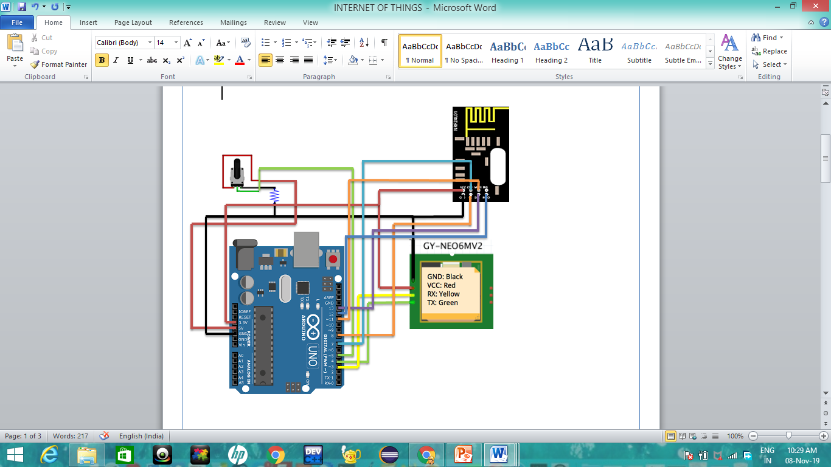

**Device**

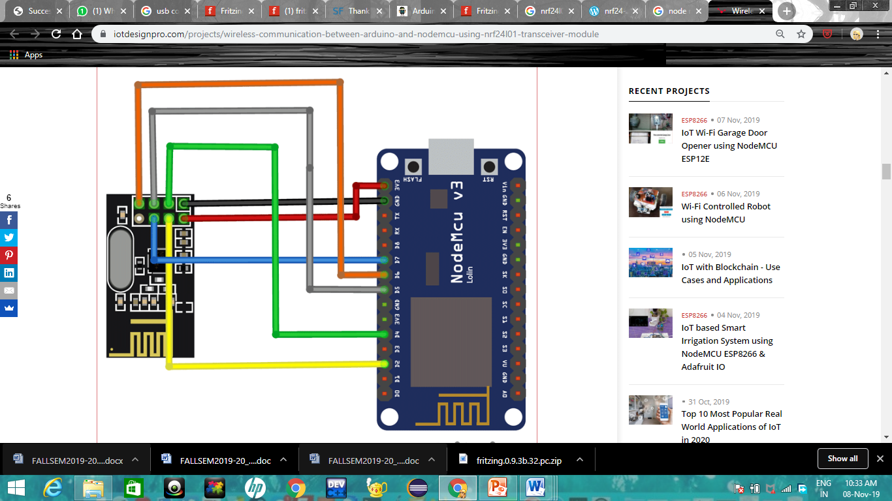

**Server connected to cloud service**

**IMPLEMENTATION**

**Block Diagram**

**GPS module interfacing with Arduino board(node1).**

**Interfacing NRF24L01 with Arduino(node1) and NodeMCU(node2) separately & establishing a radio communication in the 2.4GHz frequency band between both the nodes.**

**Sending latitude and longitude coordinates to the internet connected node when the button is pressed**

**The data received is converted to a Google map link which Is then sent to the specified email address via cloud.**

**Functional Hardware Module and Budget**

* 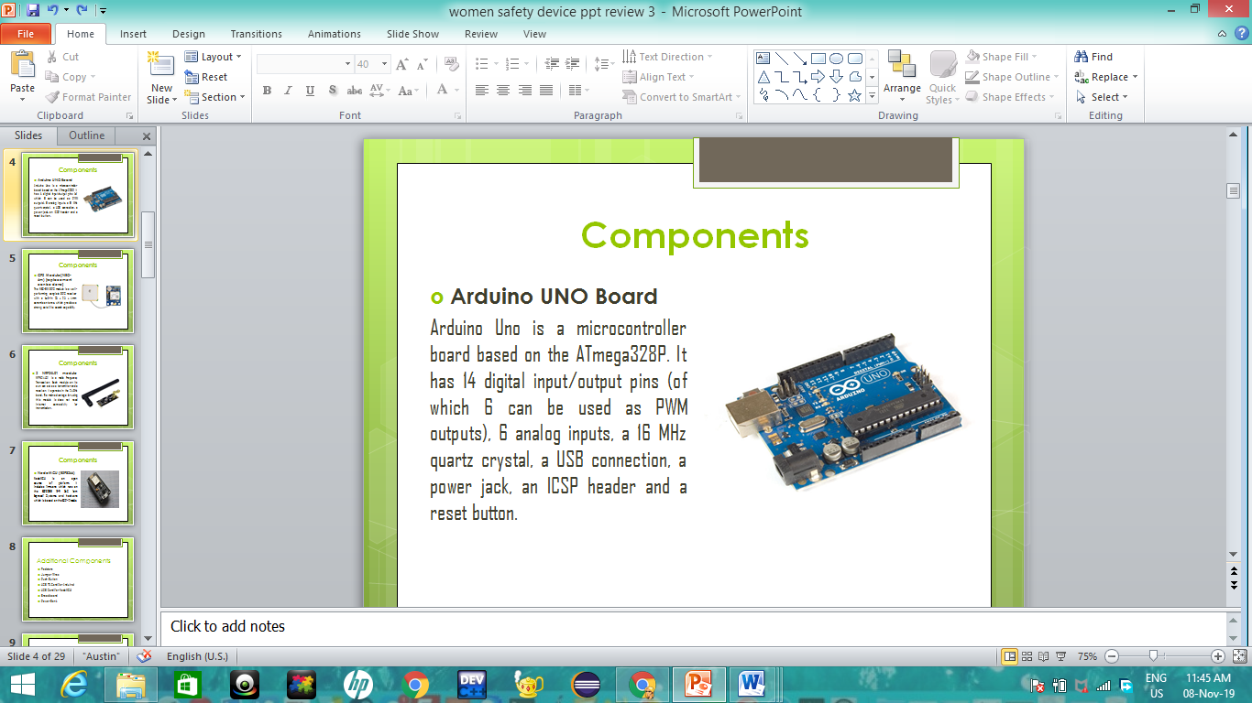**Arduino UNO Board-Rs 400**

Arduino Uno is a microcontroller board based on the ATmega328P. It has 14 digital input/output pins (of which 6 can be used as PWM outputs), 6 analog inputs, a 16 MHz quartz crystal, a USB connection, a power jack, an ICSP header and a reset button.

* 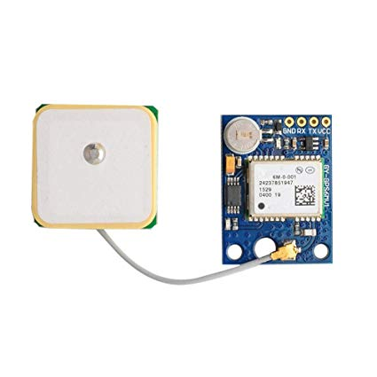**GPS Module(NEO-6M)[replacement can be done]-Rs 550**

The NEO-6M GPS module is a well-performing complete GPS receiver with a built-in 25 x 25 x 4mm ceramic antenna, which provides a strong satellite search capability.

* **2 NRF24L01 module-Rs 500**

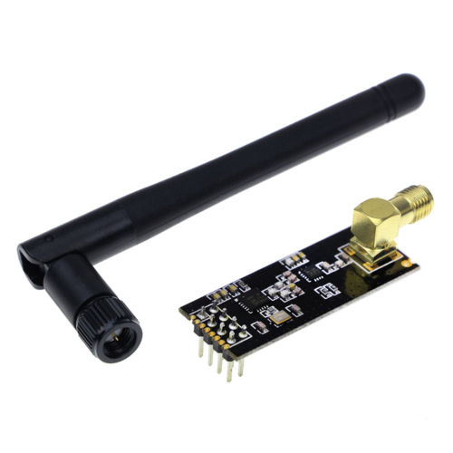NRFL24L01 is a radio Frequency Transceiver. Each module on its own can act as a transmitter and a receiver. It operates in the 2.4GHz band. The main advantage for using this module is does not need internet connectivity for transmission.

* **Node MCU(ESP8266)** **- Rs350**

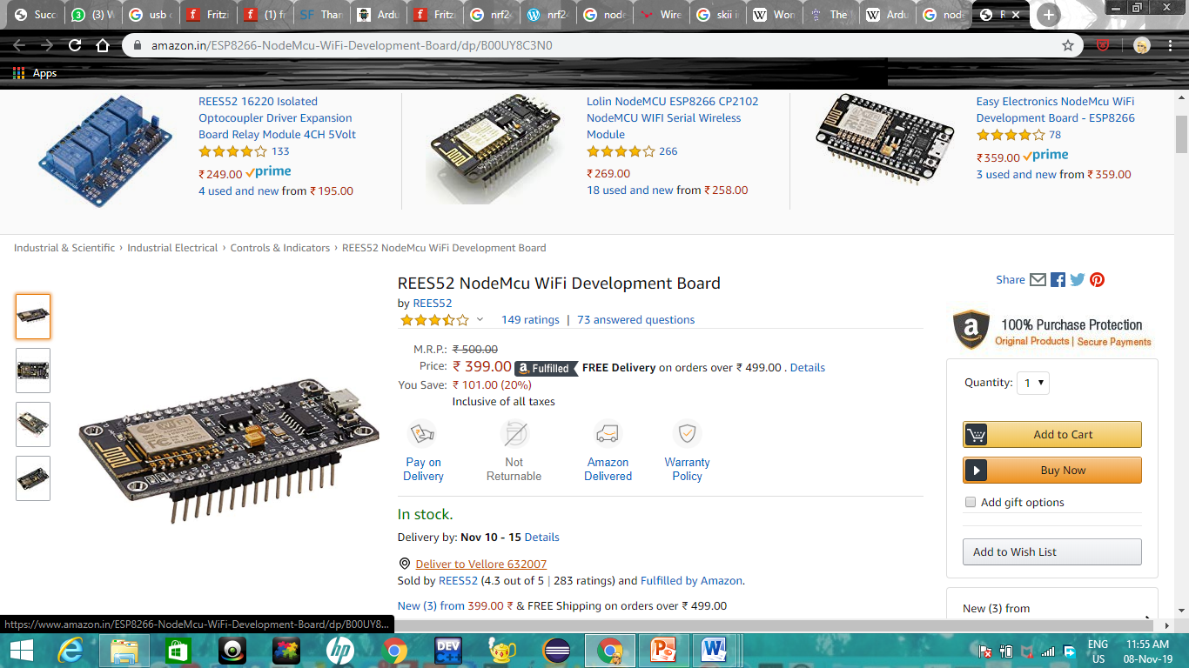NodeMCU is an open source IoT platform. It includes firmware which runs on the ESP8266 Wi-Fi SoC from Espressif Systems, and hardware which is based on the ESP-12 module.

**TOTAL BUDGET-Rs 1850**

**Additional Components**

* Resistors
* Jumper Wires
* Push Button
* USB TTL Cord(for Arduino)
* USB Cord(for NodeMCU)
* Breadboard
* Power Bank

**Software and Libraries used**

* Arduino IDE 1.8.8(software)
* SPI.h(for serial communication )
* NRF24.h(for radio frequency communication)
* RF24.h
* TinyGPS++.h(for GPS)
* ESP8266Wifi.h(Wifi)
* BlynkSimpleESP.h(for cloud service)
* SoftwareSerial.h

**SOURCE CODE**

**Uploaded on the device (Arduino UNO)**

**void loop()**

**{**

**if(digitalRead(Pushbutton)==1)**

**{**

**while (gpsSerial.available() > 0)**

**{**

**Serial.print("Latitude= ");**

**Serial.print(gps.location.lat(), 6); //Getting Latitude**

**Serial.print(" Longitude= ");**

**Serial.println(gps.location.lng(), 6); //Getting Longitude**

**Serial.print("Number of satellites in use = ");**

**Serial.println(gps.satellites.value());**

**latd=String(gps.location.lat());**

**longt=String(gps.location.lng());**

**radio.write(&latd, sizeof(latd));**

**delay(1000);**

**radio.write(&lon, sizeof(longt));**

**}}**

**else**

**delay(10);}**

**#include <SPI.h>**

**#include <nRF24L01.h>**

**#include <TinyGPS++.h>**

**#include <SoftwareSerial.h>**

**RF24 radio(7, 8); // CE, CSN**

**const byte address[6] = "00001";**

**int a=10;**

**int Pushbutton = 5;**

**static const int RXPin = 3, TXPin = 4;**

**static const uint32_t GPSBaud = 9600;**

**String latd,longt;**

**TinyGPSPlus gps; //TinyGPS Object**

**SoftwareSerial gpsSerial(4,3);//rx,tx**

**String s;**

**void setup() {**

**radio.begin();**

**radio.openWritingPipe(address);**

**radio.setPALevel(RF24_PA_MIN);**

**radio.stopListening();**

**pinMode(Pushbutton,INPUT);**

**Serial.begin(9600);**

**gpsSerial.begin(9600);**

**}**

**Uploaded on the server (NodeMCU)**

**#define BLYNK_PRINT Serial**

**#include <SPI.h>**

**#include <BlynkSimpleEsp8266.h>**

**char auth[] = "-ROVtc_MZMJaEXfE5zMiLRVTPz4NlRUl";**

**#include <nRF24L01.h>**

**#include <RF24.h>**

**#include <ESP8266WiFi.h>**

**#include <WiFiClientSecure.h>**

**RF24 radio(D4, D8); // CE, CSN**

**const byte address[6] = "00001";**

**char l1[7],l2[8];**

**String latd,longt;**

**const char* ssid = "ssid";**

**const char* password = "password";**

**String mail, loc;**

**String buff;**

**int n=0;**

**WiFiClient espClient;**

**WiFiClientSecure client;**

**void setup() {**

**mail=String("Secutiry Alert: www.google.com/maps/place/");**

**Serial.begin(9600);**

**delay(1000);;**

**radio.begin();**

**radio.openReadingPipe(0, address);**

**radio.setPALevel(RF24_PA_MIN);**

**radio.startListening();**

**Blynk.begin(auth, ssid, password);**

**Sent");**

**delay(1000);**

**n++; }}}}**

**void loop() {**

**if (radio.available()) {**

**radio.read(&l1, sizeof(l1));**

**delay(1000);**

**radio.read(&l2, sizeof(l2));**

**delay(1000);**

**Blynk.run();**

**latd=String(l1);**

**longt=String(l2);**

**Serial.print("Latitude: ");**

**Serial.print(l1);**

**Serial.print("Longitude: ");**

**Serial.println(l2);**

**if(n==0){**

**latd+=","+longt;**

**mail+=latd;**

**Serial.println(mail);**

**delay(1000);**

**Blynk.email("rajputshreya10@gmail.com", "EMERGENCY!", mail);**

**Serial.print("Notification Sent");**

**delay(1000);**

**n++;}**

**Test Cases**

**Demo: Server side Cloud Connection**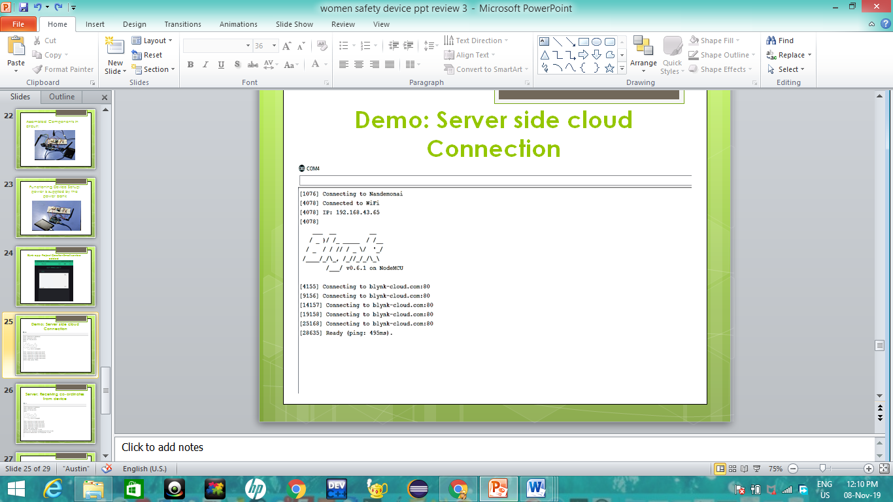

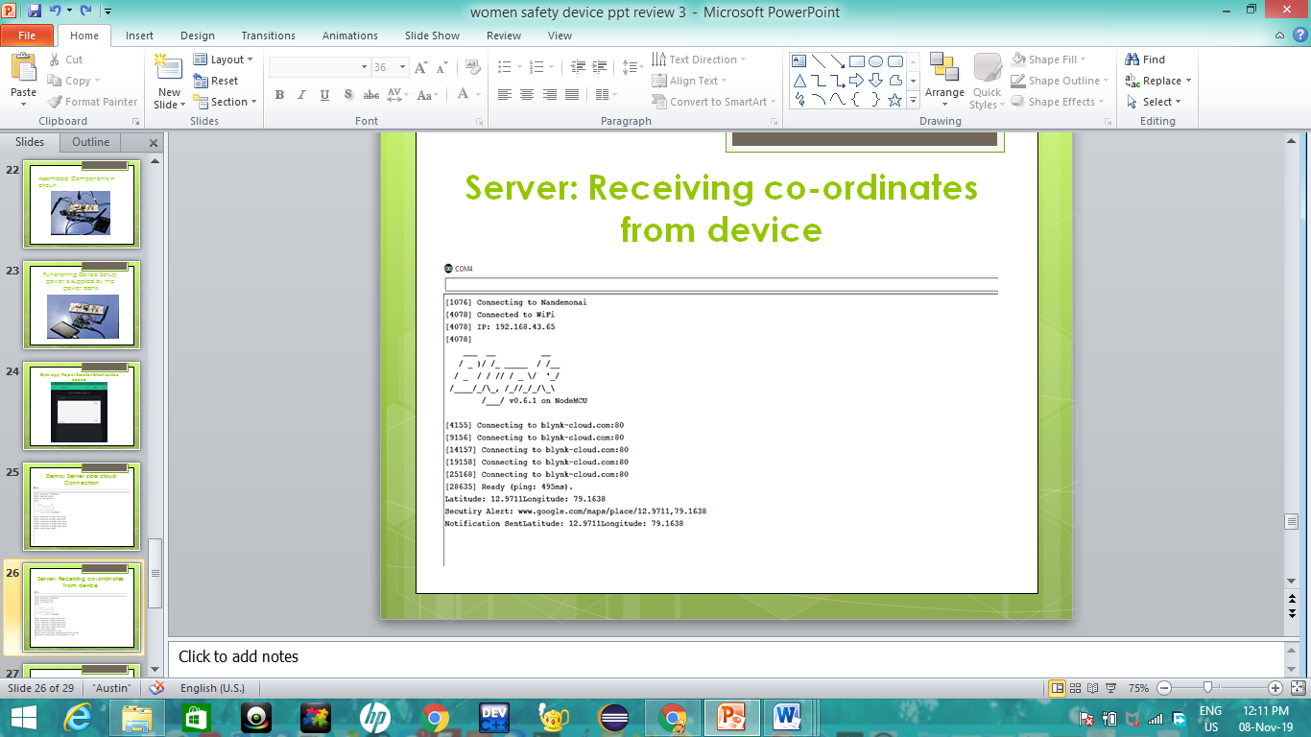**Server: Receiving co-ordinates from the device**

**Execution Snapshots**

**Outcome:**

*On pressing the button of the device, the Google map link was successfully sent to the registered email id.*

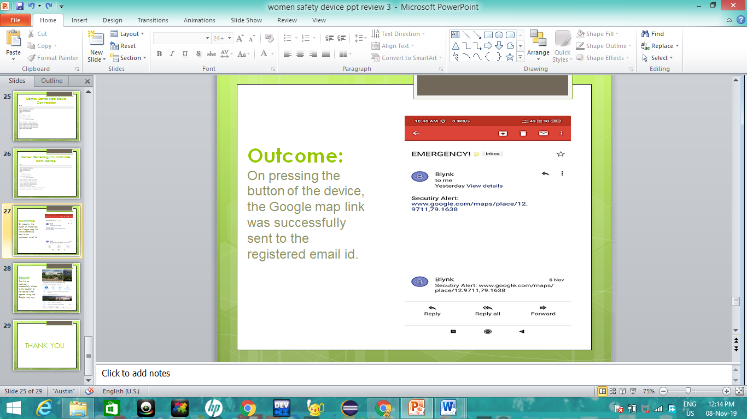

**Result:**

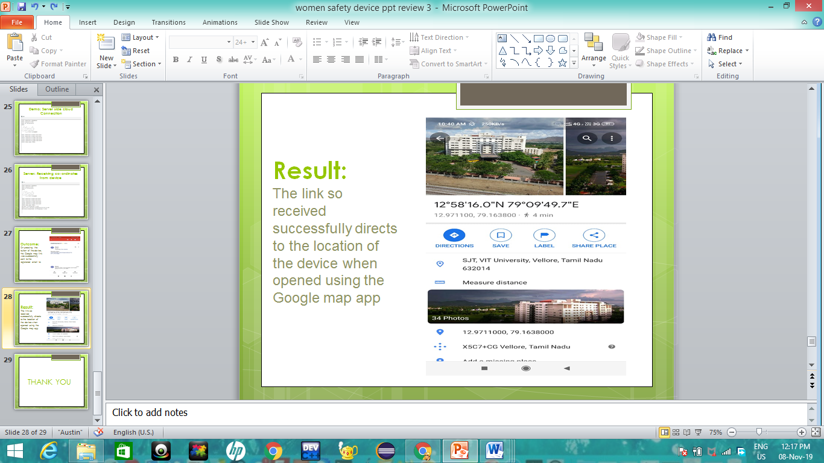*The link so received successfully directs to the location of the device when opened using the Google map app*

**CONCLUSION AND FUTURE DIRECTIONS**

The women’s safety device is the most economicalsolution for the problems faced by women in India. It provides the trusted contacts with real time location which in turn is a distress message that makes it possible to prevent major casualties. Replacing the used Arduino Uno with an Arduino Lilypad that can be sewn onto fabrics can help downsize the device. Since it uses low power, rechargeable batteries can be used to make the device more portable.

**Future Scope**

The addition of an EEG signal detection to help detect a situation of emergency as stimulated by the person in distress . This will make the device more practical and applicable in case of real-time emergencies. Once a state of emergency is detected, the device is set into its location send mode. Once the location is sent, an automated call could also be made based on the EEG signals. The electrodes which are to be placed on the scalp for reading the EEG signals can be inbuilt onto hairclips or hairbands that women usually wear. This will significantly increase the cost of the device which could be a setback. A camera module could also be fitted onto the microcontroller and this can be streamed by the GSM module as it has the ability to access the internet. The camera can give the detailed surveillance of the surroundings thus helping in planning out the possible

methods of rescue.

The women’s safety device is the most economical